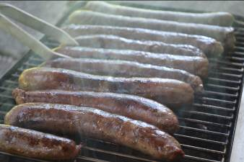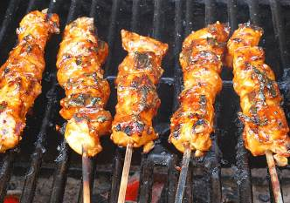Year 6 Fundraising Sausage sizzle
Wednesdays Term 4 – 2022

Our Year 6 students raise funds each year for a gift to the school. One way they do this is by helping organise a sausage sizzle each fortnight. The listed items are available for purchase every second Wednesday in Term 4 on the following dates:
- 12 October
- 26 October
- 9 November
- 23 November
- 7 December

You can either order and pay each fortnight (by the day before) OR
You can pre-order and pay for the Term (by the first day back)

Payment options:
- Cash
- Eftpos
- “Make a Payment” via our website https://hillside-p.schools.nsw.gov.au/

Thank you, Year 6

ORDER FORM – BBQ LUNCH
Students Name/s:- _____________________________

Item | Price | Qty each week | $ Amount each week
Sausage in a bread roll | $2.50
Extra sausage | $1.50
Vegetarian sausage in a bread roll (V) | $3.00
Extra vegetarian sausage (V) | $2.00
Chicken kebab in a bread roll | $3.50
Chicken kebab on a stick | $2.50
Packet of chips (V) | $0.50
Juice popper (V) | $1.00
TOTAL (ONE WEEK): |  |  |  | $
TOTAL IF ORDERING FOR THE TERM X 5 |  |  |  | $
(V) Vegetarian

